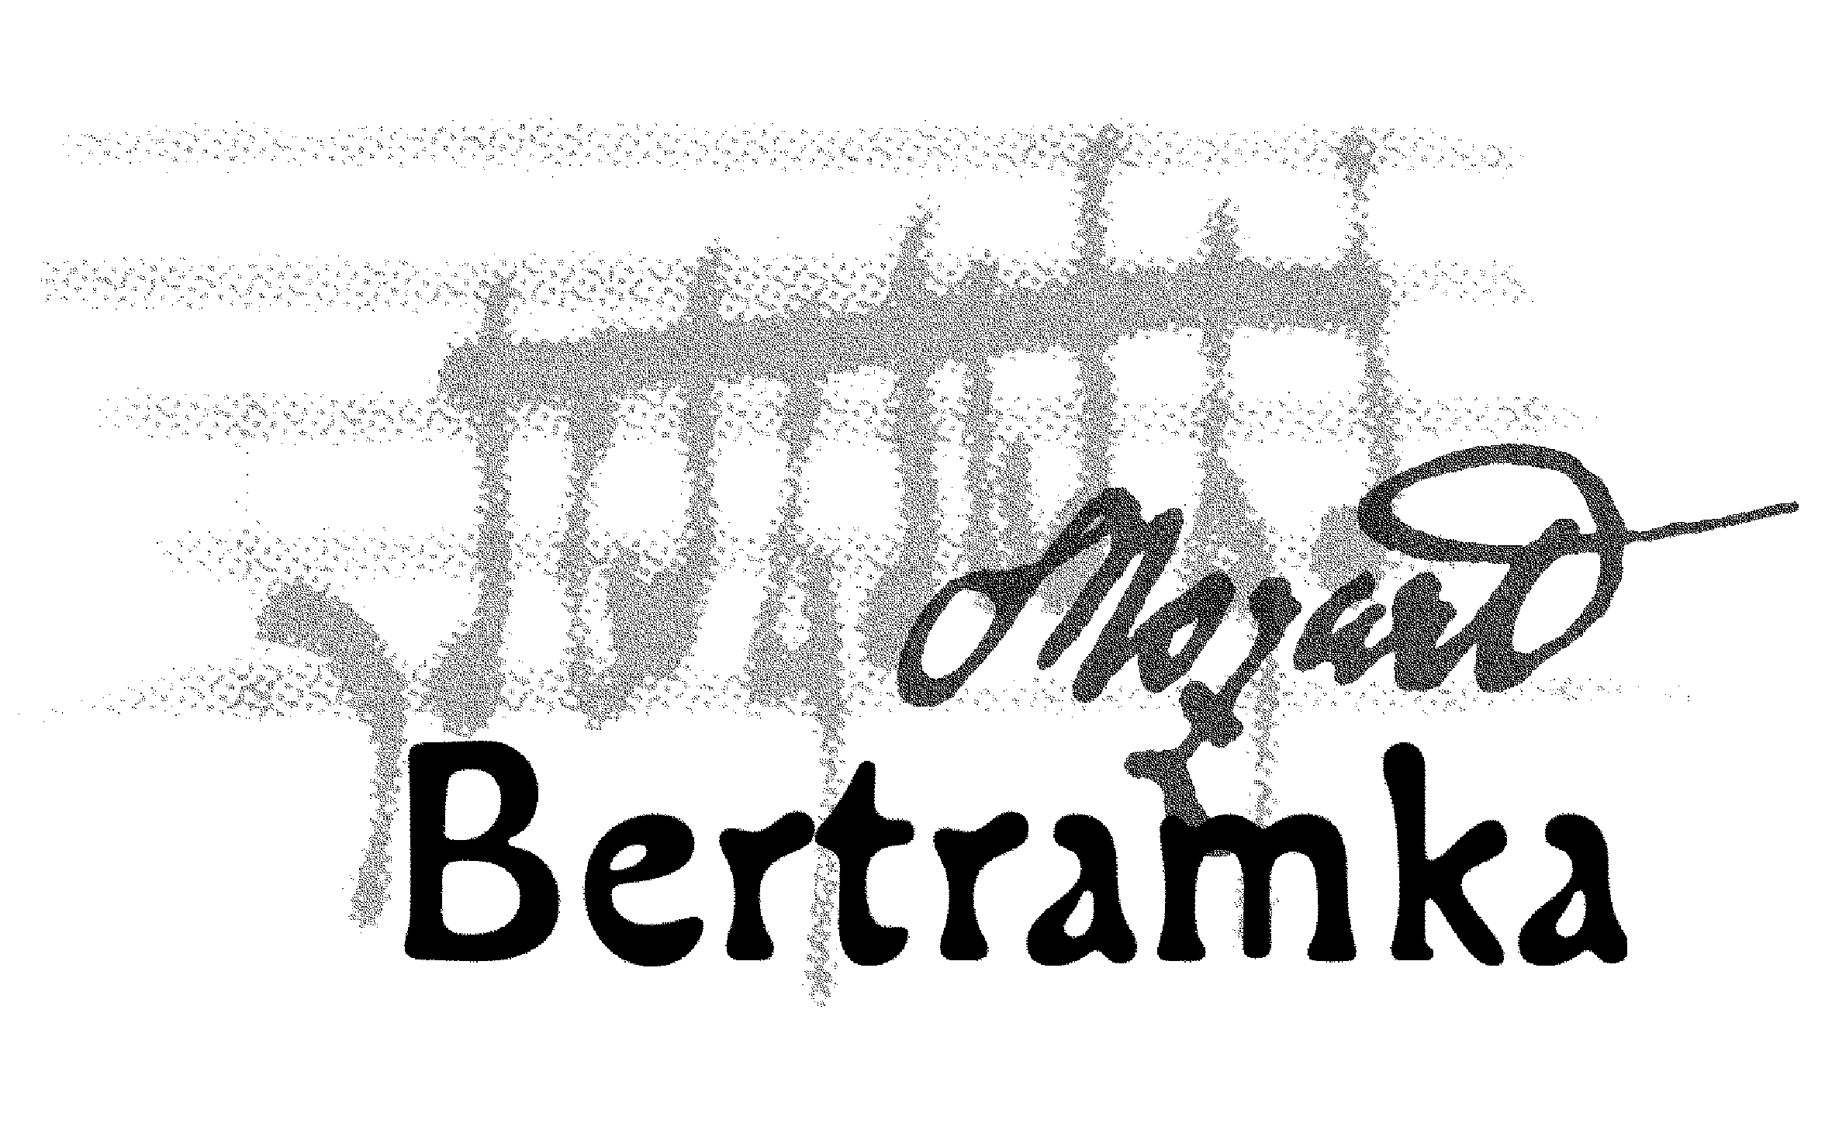
CONCERTS AT BERTRAMKA

JULY 2007

Concerts begin at 5 p.m., garden concerts at 7 p.m.

5.Thu Mozart meets Beethoven at Bertramka
Kocián Quartet (1st violin, 2nd violin, viola, cello)
W. A. Mozart: String Quartet in B flat major „Prussian“, K. 589
L. van Beethoven: String Quartet in E minor No. 8, Op. 59/2

7.Sat GARDEN CONCERT
Markéta Mátlová – soprano, Jan Thuri – oboe, Jan Kalfus – piano
W. A. Mozart: Oboe Quartet in F major, K. 370 (arr. for oboe and piano)
W. A. Mozart: Recitative and Aria for Soprano „Giunse alfin il momento“
from the opera The Marriage of Figaro
W. A. Mozart: Adagio for English horn, K. 580a
W. A. Mozart: Songs for Soprano and Piano
„Des kleinen Friedrichs Geburtstag“, K. 529
„Das Traumbild“, K. 530
„Als Luise die Briefe ihres ungetreuen Liebhabers verbrannte“, K. 520
J. Mysliveček: Sonata for Oboe and Piano
W. A. Mozart: „Vedrai, carino se sei buonino“ – Aria of Zerlina from the opera
Don Giovanni

10.Tue Mozart meets Beethoven at Bertramka
Zemlinský Quartet (1st violin, 2nd violin, viola, cello)
J. Haydn: String Quartet in G minor, Op. 74/3 „Reiter“
L. van Beethoven: String Quartet in B flat major No. 6, Op. 18
W. A. Mozart: String Quartet in E flat major, K. 428

12.Thu ArteMiss Trio (violin, cello, piano)
W. A. Mozart: Trio No. 6 in C major, K. 548
D. Šostakovič: Trio No.1
A. Dvořák: Trio in G minor

14.Sat GARDEN CONCERT

Czech Wind Quintet (flute, oboe, clarinet, French horn, bassoon)
W. A. Mozart: Adagio for Oboe and Wind Instruments, K. 580a
G. M. Cambini: Quintet No. 1 in B flat major

A. Rejcha: Quintet in A major No. 11, Op. 91

17.Tue Mozart meets Beethoven at Bertramka
Zemlinský Quartet (1st violin, 2nd violin, viola, cello)
W. A. Mozart: String Quartet in C major, K. 170
J. Haydn: String Quartet in D major, Op. 76/5
L. van Beethoven: String Quartet in E flat major No. 10 „Harp“, Op. 74

19.Thu Mozart meets Beethoven at Bertramka
Herold Quartet (1st violin, 2nd violin, viola, cello)
W. A. Mozart: String Quartet in D minor, K. 173
W. A. Mozart: String Quartet in B flat major, K. 172
L. van Beethoven: String Quartet in C major No. 9 „Razumovski“, Op. 59/3

21.Sat GARDEN CONCERT

Chamber Orchestra Camerata filharmonica Bohemia and their guests

24.Tue Brahms Trio Prague (violin, French horn, piano)
W. A. Mozart: Concerto for French horn in E flat major, No. 3, K. 447
L. van Beethoven: Romance for Violin in F major
W. A. Mozart: Sonata in A major, K. 331
J. Brahms: Trio Op. 40 for Violin, French horn and Piano

26.Thu Duo Eco (violins)
J. Aubert: Chaconne
R. M. Glière: twelve duets (selection)
W. A. Mozart: Duo No. 21
H. Wieniawski: Caprice for two violins, Op. 18
G. Ph. Telemann: Gulliver´s Suite
W. A. Mozart: Duo No. 20
A. Corelli: La Folia

28.Sat GARDEN CONCERT
LYRA DA CAMERA (harpsichord, soprano, flute, cello)
G. Ph. Telemann: „Du bist verflucht, o Schreckenstimme“ – aria for soprano,
flute and harpsichord
G. Ph. Telemann: Sonata in B flat major for Flute and Harpsichord
J. S. Bach: „Du bist bei mir“ – aria for soprano and harpsichord, BWV 508
J. S. Bach: „Air“ from the suite in D major for cello and harpsichord
G. F. Händel: „Meine Seele hört im Sehen“ from the cycle „Neun deutsche
Arien“, aria for soprano, flute and harpsichord
W. A. Mozart: „Schon lacht der holde Frühling“, aria for soprano, flute and
Harpsichord, K. 580
F. X. Dušek: Sonata in A major for Harpsichord
W. A. Mozart: „Bella mia fiamma, adio“ – aria for soprano accompanied by
Harpsichord, K. 528
W. A. Mozart: Sonata in F major for Flute and Harpsichord

31.Tue Adéla Štajnochrová – violin, David Kalhous – piano
W. A. Mozart: Variation in G major „Helas, j’ai perdu mon amant“, K. 360
for violin and piano
G. Kutág: Tre pezzi per violino violino e pianoforte, Op. 14e
L. Janáček: Sonata for Violin and Piano
R. Schumann: Sonata for Violin and Piano, Op. 121

________________________________________________________________________

BERTRAMKA – MUZEUM W. A. MOZARTA, Mozartova 169, Praha 5
Telefon: 257318461, 257317465, Tel/ fax: 257316753,
e-mail: mozart@bertramka.cz, www.bertramka.com

