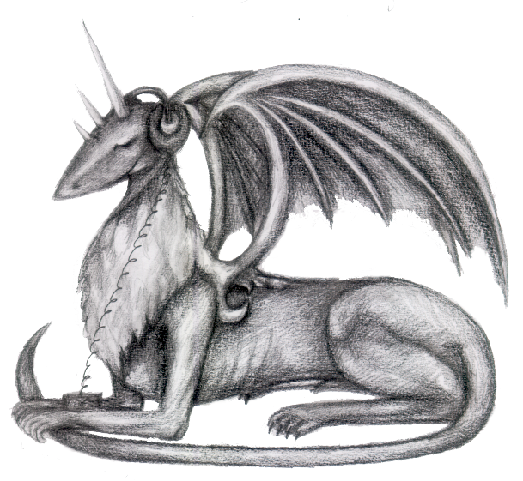

CONCERT of LAUREATES

INTERNATIONAL COMPETITION

of ELECTRO-ACOUSTIC MUSIC

(103 compositions from 29 countries)

MUSICA NOVA 2006

Premieres of the compositions in attendance of composers

H. TUTSCHKU (Germany) - ROJO
P. MCILWAIN (Australia) – INSTRUMENTAL LANDSCAPE

T. GAUTHIER (Canada) – ETUDE AUX CLAVECIN ET OISEAUX

H. VEGA (Columbia) – IDORU IN METAL
P. KOVAŘÍK (CR) – SPACE-TIME

Friday, December 15th 2006, 6 p.m.,
Czech Museum of Fine Arts, Husova 19-21,
Prague 1- Old Town

ENTRANCE FREE

Organised by Society for EA Music in cooperation with CMFA and Czech Radio
Supported by Ministry of Culture, Municipal Government, Foundation OSA, Foundation Czech Music Found

