DRUG POLICY STRATEGY

of the Capital City of Prague for the period 2008 to 2012

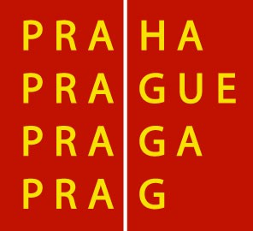

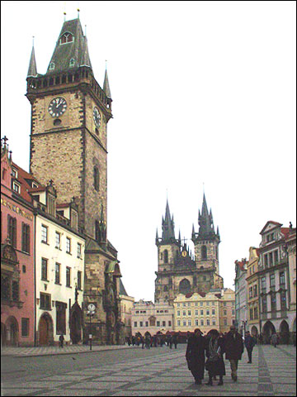

Compiled by Mgr. Nina Janyšková, Drug Coordinator of the City of Prague



KOPPR

Regional Department of Drug Prevention

Index

1 Preamble 3
2 Function of the CCP Strategy 4
3 General characteristic of the CCP 5
3.1 Unemployment 6
4 Main characteristics of the use of AS in the CCP 7
4.1 Use of drugs and provided services 7
4.2 Availability of drugs and measures to curb it 8
4.3 Services in the CCP 8
5 Starting points of the CCP Strategy 9
5.1 The problem of drug use 9
5.2 Drug Policy 9
5.3 Basic approach toward the problem of drug use 10
6 Objectives of the CCP Strategy 12
6.1 Main objectives 12
6.2 Specific objectives 12
6.3 Technical and organizational objectives 13
7 Basic framework of the Strategy 14
7.1 Strategy and Action Plan 14
7.2 Timeframe 14
7.3 Structure of the Action Plan 14
8 Roles and responsibilities of the key bodies 15
8.1 Prague City Hall 15
8.1.1 Drug Commission of the CCP Council 15
8.1.2 Sections 15
8.1.3 Regional Department of the CCP Drug Policy 15
8.1.4 Divisions of the City Hall 16
8.1.5 Division of Crisis Management 16
8.1.6 Division of social care and health 16
8.1.7 Division of education, youth and sports 16
8.2 City Districts Praha 1 to 22 16
8.3 Other 17
8.3.1 Services Network 17
8.3.2 Police Force 18
8.3.3 Resorts and the Government Council for Drug Policy Coordination 18
8.3.4 Regions of the CR 18
9 The CCP Drug Policy 19
10 Chart of the Drug Prevention 20

Preamble
The Drug Policy Strategy of the Capital City of Prague (further on as “CCP Strategy”) for the period 2008 - 2012 relays on two basic materials: the National Drug Policy Strategy for the period 2005 to 2009 closely linked to Action Plans for individual periods, and the EU Drug Strategy for the period 2005 – 2012. It is drawing on analyses and research work effectuated in the past in the field of drug policy e.g. by the National Monitoring Center, the Office of Health of the City of Prague, the Addictology Center, the Regional Department of Drug Prevention etc. Further on, the present Strategy is based on the evaluation of the Drug Policy Strategy of the Capital City of Prague for the period of 2002 to 2006 made by the Drug Commission of the CCP Council, the Regional Department of Drug Prevention and by Drug Coordinators of Districts Praha 1 to 22 in 2007.

The Capital City of Prague (further on as “”CCP”) always was and presently still is one of the Czech regions the most affected by problems related to the use of addictive substances (further on as “AS”). The use of AS represents a serious issue-generating multiple risks in security, health and social areas and concerns whole the population of the CCP. For this reason it is necessary to take such measures that would deal not only with specific, individual solutions, but treat the whole spectrum of the problem. In the CCP Strategy under AS were included illegal substances as well as the legal ones that are universally available (organic solvents) and substances highly tolerated by society (alcohol and tobacco). It is important to keep in mind that for the youth under 18 years alcohol and tobacco are equally illegal.

Since the beginning the CCP system of drug policy was built on the basis of international experience. The system mainly consists of individual programs of NGOs that swiftly responded to created demand. Within the framework of the EU the present Czech drug policy is considered as an example of good practice and in many aspects the CCP has been its initiator. Nevertheless, it would be necessary to go on improving, extending or completing some of its areas.

By the means of its Strategy the CCP is taking measures directed to reduce both demand and supply of AS. The drug policy is based on comprehensive, multidisciplinary and well-balanced attitudes to drug issues. Well-balanced reductions of illegal AS supply and demand – these are the long-term strategies tackling the drug scene.

The CCP acknowledges that effective measures can only be achieved by means of cooperation between governmental and non-governmental organizations as well as with the civic society entities from all social environments, with the respect to regional needs of city districts of the CCP. Also cooperation with foreign subjects, exploitation of findings and results of drug strategies of individual regions of the Czech Republic and of foreign countries and coordination of a common approach in drug policy are considered as very important.

Function of the CCP Strategy
The CCP Strategy is a fundamental conceptual document suggesting directions of development of the drug policy in all its areas.

The CCP Strategy has updated the previous strategy according to the latest knowledge of the phenomenon of AS use, on its consequences and effective solutions of related problems. The CCP defines the basic issues and directions of drug use problem and recommends the basic framework for the elaboration of strategies in Administrative Districts of Praha 1 to 22. Its principal functions are the following:

- Setting basic principles and goals and to establish priorities of the CCP Drug Policy for all the subjects on the level of regions, city districts and services providers.
- Drawing an institutional and organizational framework of the Drug Policy, responsibilities and competences.
- Interconnecting the local government, governmental and non-governmental organizations on all the levels of planning and implementation of the Drug Policy.
- Informing the general public and providing information on the form and the direction of the CCP Drug Policy Strategy.
- Make it possible for the services providers to find their right place in the system of prevention and treatment and to become full-value partners for the region and city districts.

The CCP Strategy is accompanied by the Action Plan (further on as “AP”) for the period 2008 to 2009. AP develops the principles drawn in the CCP Strategy, defines in detail the individual steps of the CCP Drug Policy, their deadlines and coordination in the course of individual years of the AP duration.

The CCP publishes an Annual Report on the realization of drug policy in the preceding year. The data contained in these documents not only clearly report on the evolution of drug scene in the CCP and on current tendencies of the CCP Drug Policy, but also they point to the related issues as high crime rate, unemployment, feeling of security of the CCP population etc. These reports complement the CCP Strategy and its AP.

General characteristic of the CCP
The law defines Prague as the Capital City of the Czech Republic, the commune and the region. At present it occupies a territory of 496 square kilometers with a total population of 1 212 097 (by 31.12.2007).

The territory of the CCP constitutes an integral administrative unit – the Capital City of Prague (CCP). From the point of view of the self-governance it is divided in 57 City Districts and from the point of view of the State administration executive in 22 Administrative Districts (since approx. 1.7.2001).

Map 1: Administrative Districts of the CCP after 1. 7. 2001 (22 Administrative Districts)
(source: Information server of the CCP, 2002)
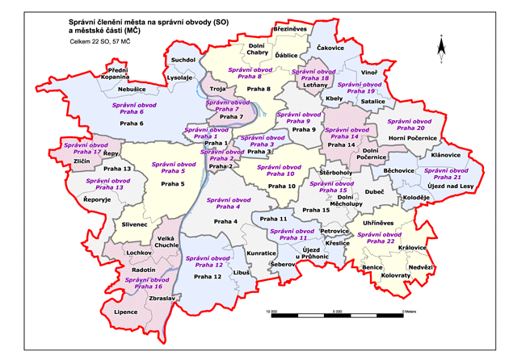

Table 1: Population of the CCP by 31. 12. 2007 compared to the population census*
(source: Statistic Yearly Book of the CCP, ČSÚ, Prague 2003 and Statistic bulletin - CCP for 2007; www site of the ČSÚ, 2008)
 | by 31. 12. 2007 | population census 2001*
Total population | 1 212 097 | 1 169 106
- male | 585 728 | 554 382
- female | 626 369 | 614 724
*) Population census of people, apartments and houses - Population census providing basic data on number and structure of the population. It is completed by a yearly statistic record on births, marriages, divorces, deceases and migration.

Table 2: Population of the CCP by Administrative Districts
(source: Statistic Yearly Book of the CCP, ČSÚ, Prague 2003 and Statistic bulletin - CCP for 2007)

CD | population |  | CD | population
CD | k 31.12. 07 | SLBD 2001 | CD | k 31.12. 07 | SLBD 2001
Praha 1 | 30 641 | 34 581 | Praha 12 | 64 941 | 62 721
Praha 2 | 47 818 | 51 003 | Praha 13 | 60 088 | 54 767
Praha 3 | 71 140 | 72 840 | Praha 14 | 45 914 | 38 529
Praha 4 | 137 449 | 137 067 | Praha 15 | 41 249 | 37 491
Praha 5 | 84 512 | 79 164 | Praha 16 | 21 285 | 18 789
Praha 6 | 110 384 | 109 741 | Praha 17 | 28 651 | 26 283
Praha 7 | 41 506 | 41 755 | Praha 18 | 23 533 | 14 275
Praha 8 | 108 256 | 108 107 | Praha 19 | 10 920 | 14 163
Praha 9 | 47 896 | 41 863 | Praha 20 | 14 276 | 13 036
Praha 10 | 110 516 | 108 609 | Praha 21 | 17 065 | 12 064
Praha 11 | 84 485 | 85 020 | Praha 22 | 9 572 | 7 238

Table 3: Number of schools, children, pupils and students in the CCP – school year of 2007-2008

Kind of school | Number of schools | Common classes/departments | Special classes/departments | Total
Kindergartens | 325 | 29 085 | 755 | 29 840
Elementary schools | 252 | 73 076 | 3 890 | 76 966
High schools | 203 | 69 265 |  | 69 265
Conservatoires | 6 | 1 353 |  | 1 353
Higher professional schools | 39 | 5 250 |  | 5 250
Total | 825 | 178 029 | 4 645 | 182 674

Unemployment
Unemployment rate in the CCP has always been significantly lower than in other regions of the CR. In 2006 it was of 2,72% and in 2007 it fell to 2,2%. Evolution of the unemployment rate in the CCP compared to the Czech Republic during the last years is shown by the following graph.

Graph 1: Comparison of registered unemployment rate in the CCP and in the CR during the period of 1993 – 2007 (data in %)
(source: database of the ČSÚ based on the data of the Ministry of Work and Social Affairs and on the Statistic bulletin - CCP for 2007)

Main characteristics of the use of AS in the CCP

Use of drugs and provided services
- Research studies confirm the relation between the presence of high rate of risk environmental factors (quality of environment, demographic and socio-economic indicators) and of the high rate of drug use, including its negative consequences differing from one region to other. The CCP is characterized by the worse social environment, concentration of criminality and “drug” crimes and by very unfavorable situation in the use of AS.
- The use of pervitin and heroin has been stabilized; the number of heroin users is decreasing as the subculture is aging. Young people have enough objective information on risks related to the use of different drugs.
- The falling tendency of the age of first experience with illegal drugs stopped.
- Experimental and casual use of cannabis drugs and ecstasy is rising, but the tendency is slowing.

- Consumption of alcohol and tobacco is continuously growing among young people as well as among older population. The issue of tobacco and alcohol is not dealt with in
a comprehensive way neither in the CR, nor in the CCP. The extended network of drug treatment establishments in the CCP is reflecting the global situation.

- Occurrence of HIV/AIDS among the users of AS is stabilized. Injection users of AS significantly contribute to the spread of virus hepatitis. The prevalence of virus hepatitis is relatively low among injection users compared to the average in EU countries.
- The most represented age group among new demands of treatment in Prague was of 25 – 39 years and of 15 - 19 years, younger age groups were stronger compared to the preceding year. More than a half of all clients in Prague were of 25 – 39 years, followed by 20 – 24 years. The age group of 25 – 39 years is also the strongest on the level of the Czech Republic.
- Number of deaths caused by drug overdose is decreasing.
- A system of certification of professional aptitude for drug services was put into place.

Availability of drugs and measures to curb it
- Availability of alcohol and tobacco to minors is practically unlimited, which is contrary to the valid law and explicitly shows how deficient is its enforcement. Alcohol and tobacco are illegal for this age category.

- There is already a legislative in place allowing hard sanctions against illegal drug traders. The police is not focusing on drug users as a priority.

- Drug supply is not significantly decreasing and is higher than the demand. Stable drug prices or their decrease are related to this situation. Higher availability of drugs is to be found at social events, in clubs and restaurants.

- The number of registered felonies related to drug criminality is rising.

Services in the CCP
- One of the CCP’s specificities is its compactness, which means that there is a good availability of services. Since 1990 a network of services covering the whole necessary range of drug prevention areas /see the map 2 and the point 10/. Primary drug prevention makes an indivisible part of activities in all schools in the CCP, and in the same time it is the mission of pedagogical-psychological consultancies, where it is provided by district prevention methodologists. It is necessary to continue in extending the network and adding new services accordingly to the evolution and to the needs of the drug situation. There are long waiting times in the methadone substitution centers.

Map 2
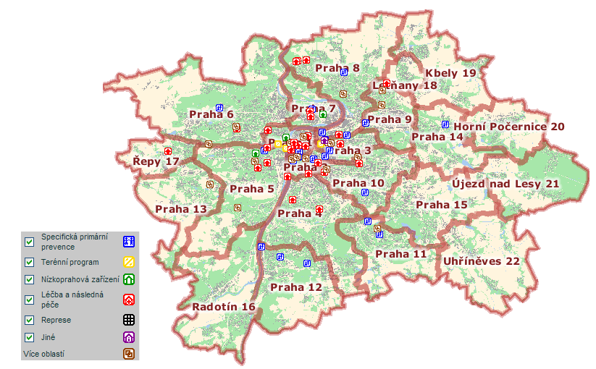
- Funds for the services of drug prevention for every calendar year are released from the CCP budget under the chapter Drug Policy. Relevant Ministries, the Council of the Government for Drug Policy Coordination and some of the City Districts are also participating to the funding of Prague drug services trough the tender procedure “The Healthy Capital of Prague”.

- Within the framework of multi-annual funding of four years, since 2006 the funds are provided to certified services.
- Principal decisions of the CCP Drug Policy are made by the Municipal Board of the CCP and/or the Council of the CCP.

Starting points of the CCP Strategy

The problem of drug use
The use of all types of narcotic and psychotropic substances is a complex and multilayered phenomenon with a whole number of interrelated potential risks for individuals and society. The drug use represents a problem endangering public health. Primarily at the issue are possible adverse social, healths, criminal, security, and economic impacts that influence on the duality of life of individuals and society in a broader social context.

Drug Policy
The drug policy is a comprehensive and coordinated set of preventative, educative, therapeutic, social, regulatory, control, and other measures, which are implemented at national, regional, and local levels. It is about the management and relationships among all subject participating to the solution of the given problem using different means. Its ultimate aim is to reduce the use of all types of drugs and/or the potential risk and damage that could occur to individuals and society as a result of the drug use.

Basic approach toward the problem of drug use
The CCP (as well as the Government of the Czech Republic) acknowledges that
a comprehensive, multidisciplinary, and well-balanced approach is required as an effective strategy to tackle the problems associated with drug use. This is an approach based on broad cooperation at all levels, and is founded on the comprehensive, research-backed, and balanced application of three basic strategies of the modern drug policy. These strategies are drug demand reduction (primary prevention, therapy and resocialization for users), reduction of risks related to the drug use (i.e. harm reduction) and drug supply reduction (controlling sale and distribution of legal drugs and clamping down on illegal distribution, production, import and export of illicit drugs). These strategies are not interchangeable; instead, they complement one another.

In this respect, the Regional Drug Policy will continue to be formed by four basic pillars – primary prevention, treatment and resocialization, risk reduction, and reduction in the availability of drugs. These pillars can be applied efficiently only in a functioning institutional environment based on scientific knowledge, on information, and on assessments of action taken so that only efficient measures and activities are funded. See the graphic of the National Drug Policy Strategy for 2005-2009.

Within the sector of education the primary prevention is dealt with in a broader context and is also related to other phenomena as defined by the Ministry of Education. The term of specific primary prevention includes not only specific primary drug prevention, but equally the prevention of risk behavior among children and youth in the sector of education.

COORDINATION

FUNDING
primary prevention | treatment and resocialization | risk reduction | reduction in availability
ACTIVITIES AIMED AT  PREVENTING DRUG USE OR  POSTPONING FIRST  EXPERIENCE OF DRUGS  TO A MORE MATURE AGE. | A RANGE OF SERVICES  RELATED TO ABSTINENCE  THERAPY FOR DRUG USERS  WHO MAKE A CONSCIOUS  CHOICE TO LIVE WITHOUT  DRUGS. | SERVICES TO REDUCE  THE POTENTIAL HEALTH  AND SOCIAL RISKS AND  IMPACTS OF DRUG USE IN  RELATION TO USERS NOT YET  READY TO GIVE UP DRUGS,  AND IN RELATION TO SOCIETY | ACTIVITIES TO ENFORCE  THE LAW IN COMBATING  THE SUPPLY OF DRUGS.
Demand Reduction |  | Harm reduction | SUPPLY REDUCTION
RESEARCH, INFORMATION, EVALUATION, INTERNATIONAL COOPERATION

© The Secretariat of the Council of the Government for Drug Policy Coordination (from the National Drug Policy Strategy for the period of 2005 to 2009)

The main principle of the CCP Drug Policy is the protection of public health based in the approved Resolution of the Government of the CR Nr. 109/04 on the preparation of the National Drug Policy Strategy for the period of 2005–2009. The European Union's Amsterdam Treaty also adheres to a concept of protecting public health.

Other principles are:

A realistic, informed approach - the drug policy will be based on an analysis of present situation and identified problems, requirements, and priorities. Its objectives will be realistic, feasible and measurable, which also means appraisable.

Partnership and a common approach - The CCP Strategy is based on partnership and broad cooperation of all elements participating to the drug policy (administration staff - services providers – politicians). A joint, coordinated approach is based on local - community, regional and national level.

A priority of verified data - all the activities of the drug policy must be based on scientifically verified facts and data, not on assumptions. It is necessary to support scientific research and to implement its results in the practice. For this reason the CCP narrowly cooperates with specialized institutions as the National Monitoring Center, Addictology Center, the Health Service of the CCP and others. In the same time the CCP is carrying on different analyses and polls by the intermediary of its own department of drug prevention and by external subjects.

A comprehensive approach and long-term planning - the process of finding solutions to the drug use problem requires a comprehensive, structured approach in which individual elements of the drug policy complement each other. Changes in the development of drug use cannot be achieved by isolated measures or actions. Experiences show us that the problem of drug use can be tackled only by long-term and continuous efforts.

Assessments of efficiency - all drug policy measures must be closely monitored and their effectiveness must be evaluated in connection with the development of trends. The CCP Strategy was structured in such a way to facilitate the evaluation of measures.

Objectives of the CCP Strategy

Main objectives
In the context of the balanced application of the three basic strategies – drug supply reduction, drug demand reduction, and reduction of potential risks related to the drug use, the Regional Strategy will have one principal objective:

To reduce the use of all types of drugs and the potential risks and damage that can afflict individuals and society due to the drug use applying the 4 strategies:

  - specific primary prevention
  - treatment and resocialization
  - risk reduction
  - reduction in availability

Specific objectives

- To stabilize or to reduce the number of problem drug users.
- Emphasis on delaying in time experimenting with legal and illegal drugs and of their casual use and on drugs-free healthy life-style.
- To improve the availability of missing services or to modify the existent ones in order to increase their availability for a broader clientele and to improve their professional level and social credit.
- To improve the quality of life of all drug users, their parents and close persons providing the availability of all types of treatment based on a comprehensive approach to the personality of the client/patient. It is related to the improvement of quality of life of the services providers (including the prevention area – pedagogues and students) by the means of adequate work possibilities and prestige in the area of Addictology. This area is still quite marginalized.
- To improve the professional level of drug coordinators of city districts, services providers, to create a synergy effect and to support mutual cooperation based on good communication.
- To increase the professional level of district and school methodologists of the prevention of risk behavior among children and youth.
- To create the appropriate economic and organizational conditions for services providers and to prevent the qualified professionals to quit.

Technical and organizational objectives
In order to achieve the specific objectives, it is necessary to improve the quality of the current system and to create a corresponding and functional organizational setting for the implementation of the set of CCP Drug Policy measures. Unless these objectives attained, it would not be possible to expect any effective achievement of specific and main objectives

- Efficient Funding
  - To continue in multi-annual funding of the programs meeting the conditions of services quality and certified by the CCP on the quality of drug services. Since 2006 the CCP has been concluding four-year contracts for selected projects. To fund appropriate programs on the basis of the needs analysis that would complete the service network and be based on verified scientific knowledge and also would be realized by qualified professionals.

- Regional Coordination
  - Due to the wide scope of drug issue in the CCP, to the importance of drug policy in the CCP within national and international contexts, and as last but not least equally due to the scope of activities scheduled by the Action Plan emphasizing on analyses, reports evaluation and work with science based resources, it will be necessary to increase the number of personnel of the Regional Department of Drug Prevention.
  - To make the system of coordination of specific primary prevention in the education sector more efficient and to support it formally. One of the principal activities in this regard is the foundation of the Methodology Center of Primary Prevention.
  - To involve the department of social care and the division of education, youth and sports by the intermediary of the Health 21 program, by the Middle-term Plan of the development of social services and by other measures in the area of prevention and treatment of drug users. In the field of security, supply reduction and crime prevention it would be necessary to cooperate with the department of crime prevention, the Police of the CR and the Police of the CCP.

- Evaluation of Activities
  - Activities should be regularly evaluated on all levels and gained knowledge applied in practice. The Strategy will be evaluated in the relation to Action Plans.

- Public Awareness
  - Provide the public, city districts and services providers with objective evidence-based information by means of a website, educational workshops, conferences, press releases, common meetings. The CCP Drug Policy is symbolized by the logo, which principal idea was the element of stylized people in one circle, place, and society. The red “headpiece” is symbolizing those who have not yet decided themselves. The red color is also interlinking the element with complementary text under the logo and expresses the readiness of the drug prevention to assist both the society and individuals. The logo will be used in relation with the Regional Drug Policy.

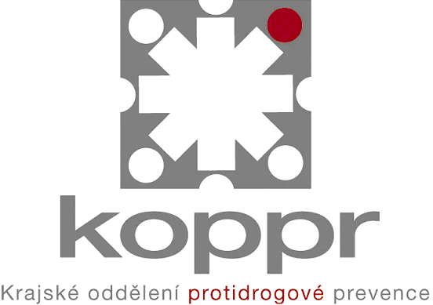

The appointed specific objectives will be developed in detail in the individual Action Plans of the CCP Drug Policy.

Basic framework of the Strategy

Strategy and Action Plan
The strategy defines the main direction of the drug policy, its main starting points, principles, objectives, and responsibilities of the entities involved, which will be applied with a view to achieving the set principal objectives.

The action plans develop the strategy and are instruments for the implementation of the strategy. The principal and specific objectives, sources, responsibilities, and individual activities are defined in detail within a set timeframe.

Timeframe
The CCP Strategy is intended to remain in force between 2008 and 2012. The first action plan was elaborated for the period 2008-2009 and will be submitted to further evaluation. The conclusions will be used to draw up the second action plan for 2010 – 2012 that would be also assessed after its implementation.

The Strategy for the period from 2012 onward will be prepared on the basis of an assessment of this CCP Strategy.

Structure of the Action Plan
Component | Characteristic
Analysis of situation | a description and analysis of the present situation, with identified problems, requirements, and priorities (SWOT analysis)
MAIN OBJECTIVE | a general objective which the drug policy aims for
Specific objectives | more specific descriptions of the situation, the drug policy wants to achieve through its activities; they support the general goal
Indicators | each specific objective should have an indicator of the achievement of the objective, and a defined method on how to verify the attainment of the objective
Strategies | methods used with a view to achieving the principal and specific objectives
Activities | each strategy is composed of a number of various activities which are planned and implemented in a logical sequence
Coordinator | the responsible department, institution, commune, employee
Output | the final products of individual activities
Milestones | as a rule, these should be reached at a certain date and in a certain order; they verify whether the planned measures and interventions are progressing in the right direction
Results | changes compared with the original situation

The structure of the Action Plan is based on the structure of the action plan approved by the Resolution of the Government Nr. 1305/2004 (NSPP 2005 -2009).

Action plans are approved by the Drug Commission of the CCP Region and for the approval are submitted to the Council of the CCP.

Roles and responsibilities of the key bodies

Prague City Hall
Principal decisions on the Drug Policy are fully within the competence of the CCP Council and of the CCP Municipal Board.

Drug Commission of the CCP Council

The Drug Commission of the CCP Council (further on as „DC CCP“) is an expert consulting and initiating organ of the CCP Council and together with the working groups is creating a platform for the individual subjects participating to realization of the CCP Drug Policy, is presenting background materials and measures to organs on regional level. DC CCP is in charge of coordination, evaluation, control and implementation of individual tasks set by the Strategy and Action Plans.

DC CCP in place since 2003 is composed as follows: the Chairman – the CCP Mayor, member of the CCP Government (1x), representative of the Government Council for Coordination of Drug Policy (1x), representative of the City Hall (1x), representatives of State institutions (3x), representatives of the NGOs (5x).

Sections

Since 2003 at the DC CCP were established four sections. These sections are working groups assisting the DC CCP in particular with the fulfillment of tasks included in the Action Plan, e.g. by processing analyses and evaluations, data collection, preparation of conferences and workshops. The sections are focused on the following areas: Section of Primary Prevention; - Section of Treatments and After-treatment; - Section of Harm Reduction; - Section of Data Collection. Regional Department of Drug Prevention is also participating to the activities of Sections.

Regional Department of the CCP Drug Policy

At the City Hall was established the Regional Department of the CCP Drug Policy (further on as “KOPPR”). In this department is working the CCP Drug Coordinator, nominated by the CCP Council, in the position of the department head, and the Regional Coordinator of the Prevention of risk behavior among children and youth. Due to the large scope of activities and of the CCP drug issues, the number of staff in the department is insufficient.

The CCP Drug Coordinator is a member and a secretary of the DC CCP, she coordinates the CCP activities in the drug area. She has a general overview of projects and financial resources. She has extended knowledge in the area of Addictology. Among other she prepares conceptual materials, printed materials for the CCP Council and the City Hall, methodological recommendations for grant applicants and for forms, evaluates final reports and funds claims submitted by services providers. She prepares specialized workshops and conferences. She collaborates with resorts, the Secretariat of the Government Council for the Coordination of Drug Policy, with governmental organizations and NGOs providing services in the field of the drug policy.

The Regional Coordinator of the Prevention of risk behavior among children and youth is in charge of - in particular – the coordination of the CCP activities in the area of specific primary prevention within the scope defined under the supervision of the Ministry of Education. She participates to the work on conceptual materials and to the realization of tenders supporting the programs of primary prevention. She has a general overview of projects. She prepares methodological recommendations for grant applicants and for forms, evaluates final reports and funds claims submitted by services providers and specialized workshops and conferences. She collaborates with the Ministry of Education.

The KOPPR annually produces reports on the implementation of the drug policy during the preceding year, which represent fundamental evaluation material based on many information resources. Thus, the department is in charge of processing of data from divers analyses, questionnaires and reports.

Divisions of the City Hall

Implementation and coordination of the CCP Drug Policy would not be possible without the cooperation of individual persons, divisions and organizations inside and outside of the City Hall.

Division of Crisis Management
Cooperation with the department of crime prevention: exchange of information; assessment of projects participating in tender procedures – the area of specific primary prevention (specific primary prevention of risk behavior among children and youth).

Division of social care and health
Exchange of information; cooperation in the evaluation of social grants and in the preparation of conceptual materials.

Division of education, youth and sports
Exchange of information; cooperation in the evaluation of projects/demands in tender procedures of “Prague – the Healthy City” and in the preparation of conceptual materials - Long-term objective of the education.

City Districts Praha 1 to 22
For the provision of specific primary prevention the CCP considers as indispensable to transfer progressively a part of its own competences to the City Districts Praha 1 to 22, in particular for the reason that it is necessary to take into account local specific conditions and needs. Resulting is a higher efficiency of programs and better possibilities for the control of funds use. The local community related to the environment and to families and the offices of city districts play an important role in the primary prevention, in particular, creating and extending the offer of preventive, leisure and sport programs for children and youth. The transfer of competences has to be realized with the active support and cooperation of the CCP, namely also the financial one with a feed-back to the Strategy and Action Plans of the CCP Drug Policy for the period 2008 - 2012.

In different proportions, the city districts develop their own drug policies and plans. Differences in the perception of a necessity of drug policy are then reflected in certain aspects as for example in the contract, position and function of the drug coordinator, establishment of the drug commission, support of specific services and the proportion of their funding.

Drug Coordinators of the City Districts Praha 1 to 22 play an important role at the realization of activities in their districts. In particular, they represent a source of information, coordinate partial activities and implement necessary measures mostly on the level of specific primary prevention. On the methodology level they are managed by the CCP Drug Coordinator. They forward and receive information and contribute with inspiration and background materials to the common measures. They meet every month in regular meetings at the City Hall. Beside these meetings they are operatively informed on all substantial decisions of the regional and State organs. The KOPPR organizes twice a year a two-day outdoor specialized workshop, where they are meeting also with the DC CCP members. Drug Coordinators of the City Districts Praha 1 to 22 are the guarantors of the meaningful and efficient use of funds from the CCP budget. They submit their final reports on program implementation and claims of funds to the CCP Drug Coordinator. Through consultations they participate to the creation of regional conceptual materials.

The work of Drug Coordinators is often decisive, as they are in charge of successful cooperation of key subjects at the city districts.

By the CCP pedagogic-psychological consultancies were appointed District Methodologists of the prevention of risk behavior in the resort of education. Their task is to assist with provision of the primary prevention on local level, with consultancy services and early intervention when problems arise in school establishments. In principle they operate as an information source, participate to the education of school prevention methodologists, they coordinate them on methodology level and realize any necessary measures mostly on the level of specific primary prevention. On methodology level they are coordinated by the Regional School Coordinator of the risk behavior prevention. They meet at regular meetings 4x a year at the City Hall. Outside of these meetings they are operatively informed on all important decisions of the regional and State organs. District methodologists cooperate with school prevention methodologists appointed in the CCP in all types of schools.

Other

Services Network

The network of services providers of drug prevention in the CCP is mainly constituted by non-profit non-governmental organizations (further on as “NGOs”). The representation of NGOs is changing accordingly to the type of prevention. While in the specific primary prevention the network is constituted of a large part by State institutions as schools and school establishments, in other types of drug prevention it is the exact contrary. In certain types of the prevention, e.g. the harm reduction, no State organizations are present.

The NGOs are mostly civic associations or public benefit societies. They obtain funds mostly from the State Budget – subsidies from the individual resorts, the Government Council for the Coordination of Drug Policy and from the CCP and City District budgets.

Organizations submit their intermediary reports on project realization to the KOPPR by 30. 6. and final reports by the end of every calendar year. Reports are accompanied by a statement of accounts of the allocated funds. Implementation of projects is verified and evaluated. Reports are used by the KOPPR as basic materials for the preparation of annual reports on the realization of the CCP Drug Policy in the preceding year.

Services providers are staying in contact with the KOPPR, they obtain and provide valuable information on the situation and the evolution of the drug scene in the CCP.

The CCP closely cooperates with specialists’ societies, in particular with the Addiction-Related Disease Society of the J. E. Purkyně Czech Medical Society, with the A.N.O. - Association of Independent Organizations specializing in the prevention and treatment of drug addiction and with the Addictology Center.

Regarding data collection and evaluation of the situation at the drug scene in the CCP is very important the cooperation with the National Monitoring Center and the Health Service of the CCP.

Police Force

The Police of the CR and the Municipal Police of the CCP constitute a special component of State organizations.
The police is responsible for the realization of concrete measures associated with the efforts of curbing the supply of illicit drugs, for the control of enforcement of legal dispositions regulating the sale of legal drugs (alcohol and tobacco), for the protection of public order and security and the repression of criminality related to all types of drugs.

Prevention department of the Municipal Police of the CCP realizes its own programs of primary prevention, in particular of criminality, and non-specific prevention of drug use and crime-rate related to their distribution.

Resorts and the Government Council for Drug Policy Coordination

Ministerial resorts and the Government Council for Drug Policy Coordination (further on as “GC DPC”) are fundamental coordination elements of individual types of the drug policy on State level. All the drug policy strategies of regions are based on the National Strategy.

The network of services providers in the CCP is funded from the public purse by subsidies from the individual resorts and from the GC DPC.

Regions of the CR

The CCP Drug Coordinator cooperates with regional drug coordinators in the Committee of Representatives of the Regions by the GC DPC. She is actively participating to meetings, information workshops and educational programs organized by the Secretariat of the GC DPC.

The Regional School Coordinator of the prevention of risk behavior among children and youth cooperates with other regional school coordinators. She is actively participating to meetings, information workshops and educational programs organized by the Ministry of Education.

The CCP Drug Policy

Council of the Government for the Coordination of Drug Policy
↑
↓
Ministry of Health | Ministry of Education, Youth and Sports | Ministry of Interior | Ministry of Work and Social Affairs | Ministry of Justice | Ministry of Defense | Ministry of Finance
↑
↓
KOPPR |  | Capital City of Prague |  | CCP Sections

↑
↓

NGOs | City Districts Praha 1 - 22 | State organizations | Municipal Police of the CCP, Prevention Unit
Private schools; specialized health and social organizations | Drug Coordinators ; District Prevention Methodologists in education | Schools and school establishments; specialized health and social organizations

Chart of the Drug Prevention
Primary Prevention – education to the healthy life-style – to the positive values
Schools  School Prevention Methodologists |  |  | Pedagogic-psychological consultancies  District Prevention Methodologists |  |  |  | Other school establishments
City Districts Praha 1 - 22  Drug Coordinators |  |  |  | Specialized organizations of primary prevention |  |  | Physicians of primary prevention

Treatment and after-treatment
Detoxication in institution, ambulatory

Psychiatric institutions |  | Ambulatory treatment |  | Daily stationary

Therapeutic communities |  |  |  | AT ordinations AT lines |  |  | Department of addiction treatments
Protected housing Protected workshops |  |  | After-treatment Centers |  |  |  | Social Work Agencies

 |  |  |  |  |  |  |  | Substitution Centers
 |  |  | Harm Reduction
Field work |  |  |  |  |  |  |  | Low threshold drop in centers
 |  |  | Repression
Work of the police organs, customs and penitentiary services, the justice

Clamping down on drug supply |  |  |  |  |  |  |  | Department for addicted convicts

⁶ The Act Nr. 131/2000 Sb., on the Capital City of Prague, as amended.
ČSÚ (www site), Statistic bulletin of the CCP for 2007.
By the generally binding decree Nr. 55/2000 Sb. of the CCP publishing the Status of the Capital City of Prague, as amended.
Truancy, bullying, racism, xenophobia, vandalism, criminality, delinquency, use of addictive substances (tobacco, alcohol and narcotics), HIV/AIDS disease and other infectious diseases related to narcotics use, dependence on political and religious extremism, netolism (virtual drugs) and pathologic gambling. Metodický pokyn k primární prevenci sociálně patologických jevů u dětí, žáků a studentů ve školách a školských zařízeních, č.j. 20 006/2007-51, MŠMT.

